# Beta Test Manual

## Introduction

This document is designed to instruct a free-use beta test to ensure that all task coverage has been completed as part of the test. Please feel free to further explore functionality and record any feedback.

## Tasks

Below is a list of tasks for each user-category, as each user category perform the below tasks as requested using the user manual to ensure that these tasks can be properly completed. Once an activity is completed please write feedback in the space provided and include proof that the activity was completed. (i.e. include a screenshot)

## As an administrator

### Periodically it is advised that you change your password, please do that now.

Did you encounter any issues during this task?

**Yes. If I change the password, the new password and confirm password don’t have to match. Fairly sure it uses the “confirm password” as your password.**

### A new team member has started with the company, can you please add a resource for that person with skills that are appropriate for that user.

Did adding a resource to the system seem easy?

**Yes it worked as expected.**

### While adding a new team member you have noticed that a skill that the resource had did not exist please go create this skill in the system.

Could this process make sense?

**Yes, had no issues doing this.**

### Now a resource profile has been created create a user profile and link it to the resource profile you have created

Could this process be improved?

**No big issues, but you might want to try to call that heading “link to resource”.**

### You have been tasked with a new project, please create the project and assign resource requirements to it.

Is this process as simple as it should be?

**Yup this section works well.**

### Assign resources to your requirements where appropriate

Did you have any requirements which couldn’t be filled? How could you fill them?

**This does not seem to work. I get the following screen with no names or hours:**

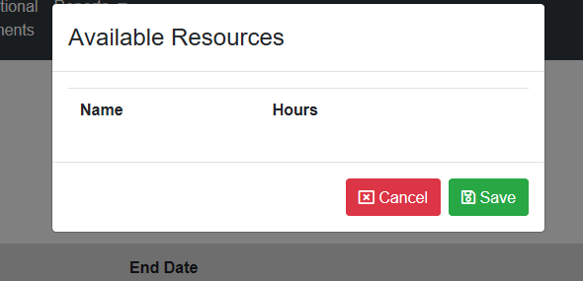

### You have been asked to create a list of required skills in the organisation over the next 6 months.

Do the reports meet your expectations

**The charts need axes and a title, not sure what the timeframe of the report is.**

## As a user

1. **Check your notifications to see if you have been assigned to a new task since you last logged in.**

Were notifications easy to use?

__________________________________________________________________________________

__________________________________________________________________________________

__________________________________________________________________________________

1. **View upcoming projects which you could join**

Is this task simple

__________________________________________________________________________________

__________________________________________________________________________________

__________________________________________________________________________________